DEPARTMENT OF COMPUTER SCIENCE AND ENGINEERING WITH SPECIALIZATION IN ARTIFICAL INTELLIGENCE AND MACHINE LEARNING

COURSE: SOFTWARE ENGINEERING AND PROJECT MANAGEMENT | CODE: 21CSS303T

PROJECT REPORT
PROJECT APPROVAL SYSTEM

Submitted by
Student Name: SWETHA K
Register Number:
RA2311026050214
Institution:
SRM INSTITUTE OF SCIENCE AND TECHNOLOGY
Faculty:
Dr.M.Padmapriya
Submission Date:

Abstract
The Project Approval System is a web-based application designed to simplify and automate the process of project submission, review, and approval in academic or organizational environments. In traditional systems, project approval is often carried out manually through paperwork or email communication, which can lead to delays, lack of transparency, and difficulty in tracking project status. This system aims to overcome these challenges by providing a centralized digital platform for efficient project management.
The main objective of the system is to enable students or employees to submit their project proposals online and allow administrators, guides, or reviewers to evaluate and approve them systematically. The system ensures proper communication between users, reduces manual errors, and speeds up the approval process. It also maintains a structured database where all project details, submission history, and approval status are securely stored and easily accessible.
The application consists of different modules such as user registration and login, project submission, project review, approval/rejection mechanism, and status tracking. Each user is assigned specific roles and permissions, ensuring secure and role-based access control. The admin or reviewer can provide feedback, request modifications, or approve the project based on predefined criteria.
This system is developed using modern web technologies and follows a modular design approach, making it scalable and easy to maintain. It improves efficiency, enhances transparency, and reduces the time required for project approval. Additionally, it provides a user-friendly interface that simplifies interaction for both students and administrators.
In conclusion, the Project Approval System offers a reliable and efficient solution for managing project approvals digitally. It not only reduces paperwork but also ensures better organization, accountability, and faster decision-making in the project evaluation process.

Table of Contents

1 INTRODUCTION...............................................................................................................................4
1.1 Overview of Project Approval System ..............................................................................................4
1.2 Problem Statement .............................................................................................................................5
1.3 Objectives of the System ...................................................................................................................6
1.4 Scope of the Project ...........................................................................................................................7
2 LITERATURE SURVEY ..................................................................................................................8
2.1 Existing Systems ...............................................................................................................................8
2.2 Limitations of Existing Systems ........................................................................................................9
2.3 Proposed System ..............................................................................................................................10
3 SYSTEM ANALYSIS .......................................................................................................................11
3.1 System Requirements ......................................................................................................................11
3.2 Functional Requirements .................................................................................................................12
3.3 Non-Functional Requirements .........................................................................................................13
3.4 Feasibility Study ..............................................................................................................................14
4 SYSTEM DESIGN ...........................................................................................................................15
4.1 System Architecture ........................................................................................................................15
4.2 UML Diagrams ...............................................................................................................................16
4.2.1 Use Case Diagram ........................................................................................................................16
4.2.2 Class Diagram ..............................................................................................................................17
4.2.3 Sequence Diagram .......................................................................................................................18
4.2.4 Activity Diagram ..........................................................................................................................19
5 IMPLEMENTATION .....................................................................................................................20
5.1 Tools and Technologies Used .........................................................................................................20
5.2 Module Description .........................................................................................................................21
5.3 Code Snippets ..................................................................................................................................22
6 TESTING ......................................................................................................................................... 23
6.1 Test Cases ....................................................................................................................................... 23
6.2 Test Results .................................................................................................................................... 24
7 RESULT AND DISCUSSION .................................................................................................................................................................. 25
8 CONCLUSION AND FUTURE SCOPE ..................................................................................... 26
8.1 Conclusion .................................................................................................................................... 26
8.2 Future Enhancements .................................................................................................................... 27
9 REFERENCES ............................................................................................................................... 28
10 APPENDIX ................................................................................................................................... 29

Introduction

1.1 Overview of Project Approval System

The Project Approval System is a web-based application developed to automate and manage the process of project proposal submission, evaluation, and approval. In many academic institutions and organizations, project approval is an essential step before starting any work. Traditionally, this process is carried out manually using paper-based documentation or email communication, which leads to inefficiency and delays.

This system provides a centralized platform where users such as students or employees can submit their project proposals online. The submitted projects are then reviewed by authorized persons such as faculty members, project guides, or administrators. Based on the evaluation, the project can be approved, rejected, or sent back for modifications.

The system ensures proper communication between all users, maintains records of all submissions, and provides real-time updates on project status. It improves transparency and accountability in the approval process.

1.2 Problem Statement

The traditional project approval process suffers from several limitations that affect efficiency and productivity. Some of the major problems include:

Manual Processing: Paper-based or email-based systems are time-consuming and prone to human errors.

Lack of Transparency: Users cannot easily track the status of their project submissions.

Data Mismanagement: Important project data may be lost or misplaced.

Communication Gap: Delays occur due to improper communication between students and reviewers.

No Centralized System: Data is scattered and difficult to manage.

Due to these issues, there is a strong need for an automated system that can streamline the entire process.

1.3 Objectives of the System

The main objectives of the Project Approval System are:

To develop an automated system for project submission and approval

To reduce manual work and paperwork

To provide a user-friendly interface for easy interaction

To ensure secure storage and management of project data

To enable real-time tracking of project status

To improve communication between users and administrators

To maintain a structured and organized database

1.4 Scope of the Project

The scope of this project includes the development of a web-based application that can be used by educational institutions and organizations. The system supports multiple users with different roles such as students, administrators, and reviewers.

The system allows users to submit projects, view status, and receive feedback. Administrators can manage users, review submissions, and approve or reject projects. The system can be further expanded by integrating advanced features such as notifications, analytics, and mobile support.

2. LITERATURE SURVEY
2.1 Existing Systems
In many institutions, project approval is carried out using traditional methods such as manual paperwork or email communication. Some organizations use basic digital tools like spreadsheets to track project details.
These systems lack automation and require significant manual effort. There is no proper structure for storing and retrieving data efficiently.

2.2 Limitations of Existing Systems
The existing systems have several drawbacks:
- Time-consuming approval process
- Lack of real-time tracking
- Increased chances of data loss
- Poor communication between users
- No proper data security
- Difficult to manage large number of projects
These limitations reduce the overall efficiency of project management.

2.3 Proposed System
The proposed Project Approval System is designed to overcome the limitations of existing systems. It provides a centralized web-based platform that automates the entire workflow.
Key features include:
- Online project submission
- Automated approval workflow
- Role-based access control
- Secure database management
- Real-time status tracking
This system enhances efficiency, accuracy, and transparency.

3. SYSTEM ANALYSIS
3.1 System Requirements
Hardware Requirements
- Computer or Laptop with minimum 4GB RAM
- Internet connection
- Storage space for database
Software Requirements
- Operating System (Windows/Linux)
- Web Browser (Chrome/Firefox)
- XAMPP Server
- Programming Languages: PHP, HTML, CSS, JavaScript
- Database: MySQL
3.2 Functional Requirements
Functional requirements define what the system should do:
- User Registration and Login
- Project Proposal Submission
- Project Review and Feedback
- Approval or Rejection of Projects
- Status Tracking
- Admin Management of Users and Projects

3.3 Non-Functional Requirements
Non-functional requirements define system performance:
- Security: Data should be protected from unauthorized access
- Performance: System should respond quickly
- Usability: Easy to use interface
- Reliability: System should work without failure

3.4 Feasibility Study
- Technical Feasibility: The system can be developed using available technologies like PHP and MySQL.
- Economic Feasibility: Development cost is low and affordable.
- Operational Feasibility: Easy to use and implement in real-world scenarios.

4. SYSTEM DESIGN
4.1 System Architecture

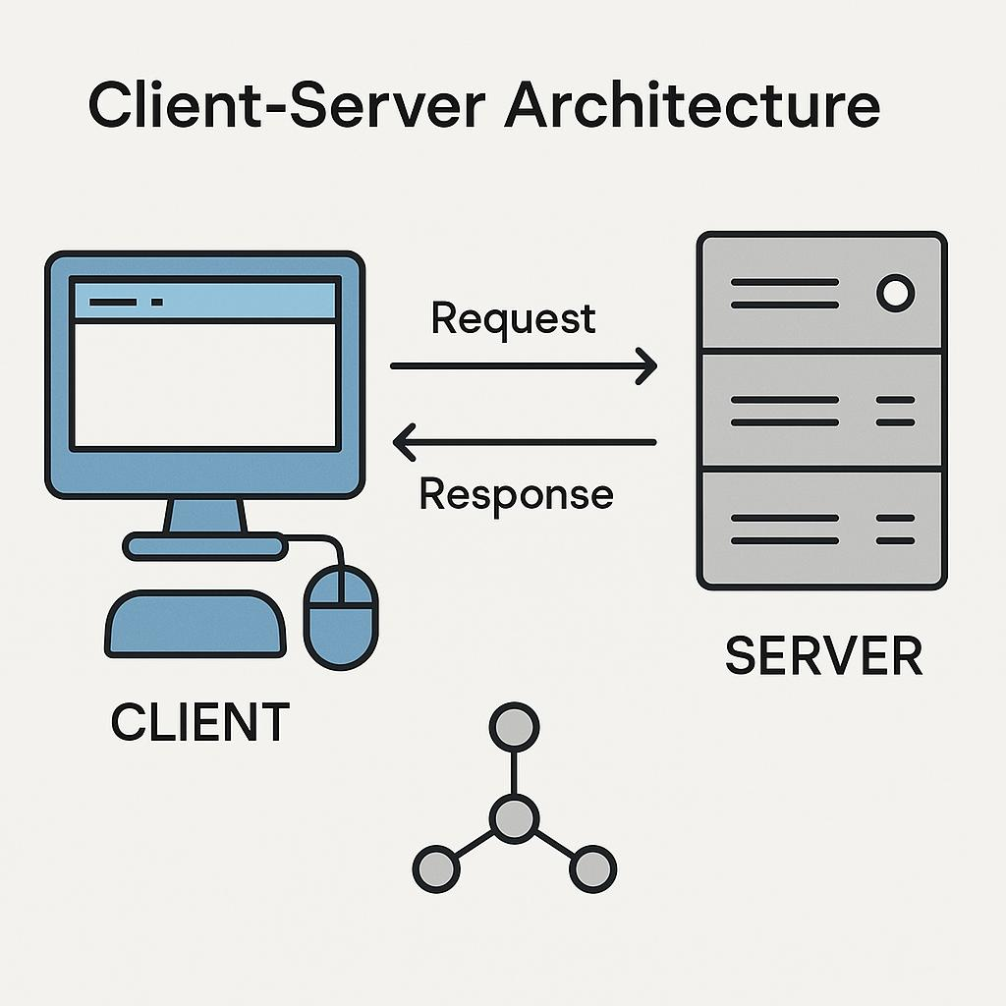

Figure 4.1: System Architecture

4.2 UML Diagrams
Use Case Diagram
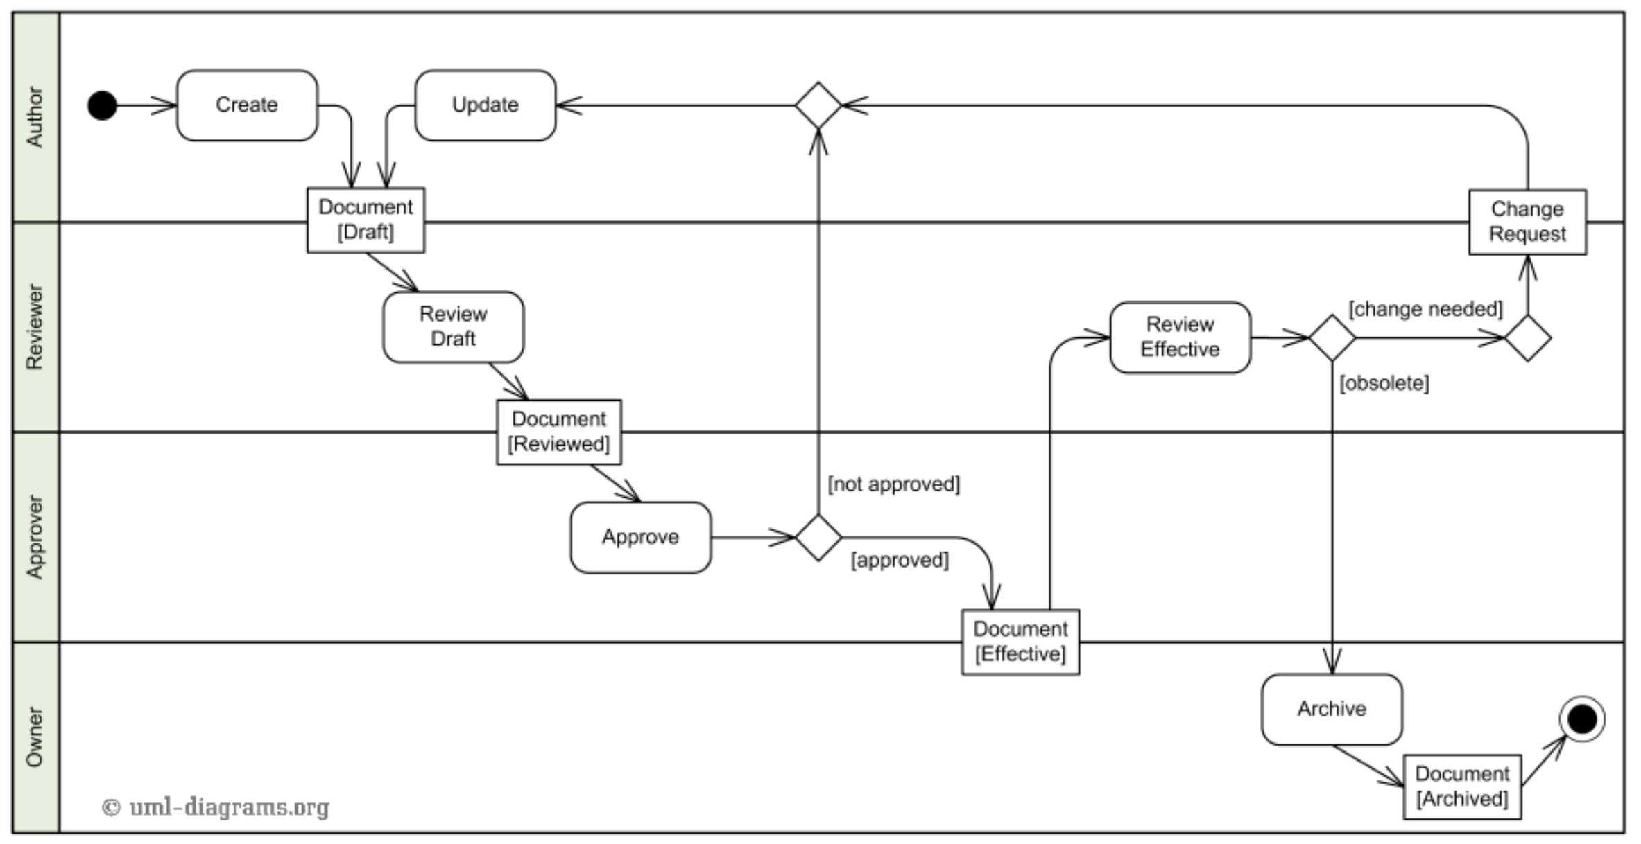

4.3 Sequence Diagram
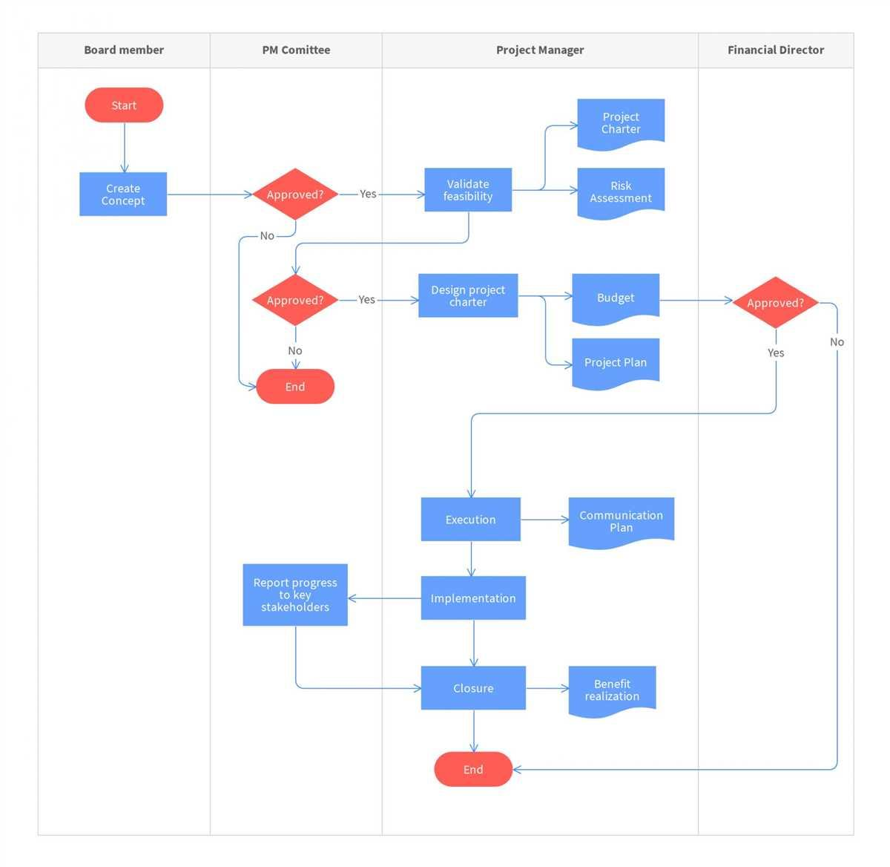

5. IMPLEMENTATION
5.1 Tools and Technologies Used
The system is developed using modern web technologies:
- HTML, CSS for frontend design
- JavaScript for interactivity
- PHP for backend processing
- MySQL for database management
- XAMPP for local server

5.2 Module Description
The system is divided into modules:
- User Module: Handles registration and login
- Project Module: Handles submission of projects `
- Admin Module: Manages users and approvals
- Approval Module: Processes approval or rejection
Each module is designed independently for better performance.

5.3 Code Snippets
Sample codes include:
- Database connection
- Login authentication
- Form submission handling
These codes ensure system functionality.
6. 6. TESTING
6.1 Test Cases
Various test cases are used:
- Login validation
- Project submission test
- Approval process test

6.2 Test Results
All functionalities are tested and verified. The system works correctly without major errors.

7 RESULT
DISCUSSION
1. Login & Registration Output
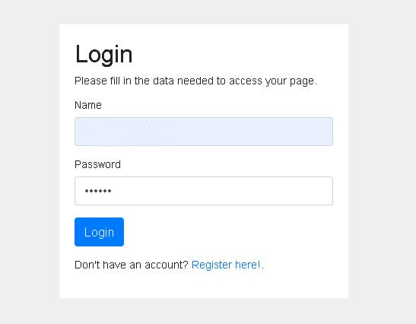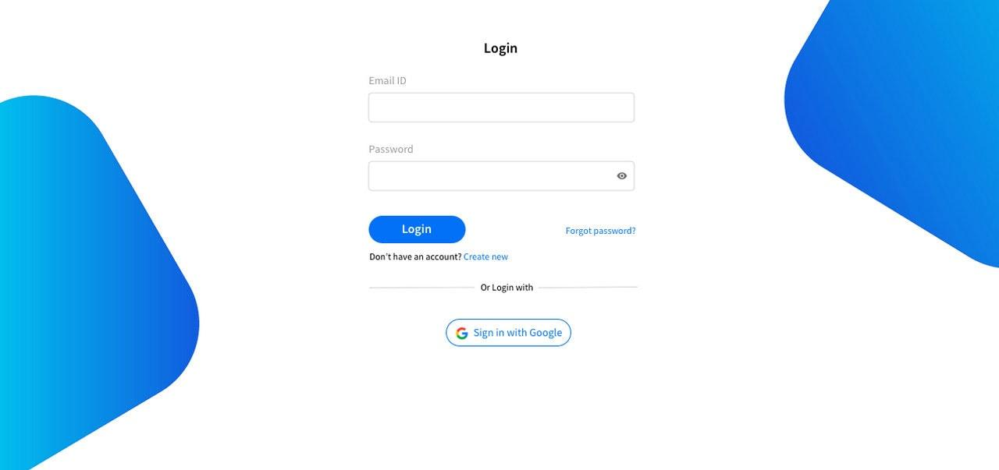
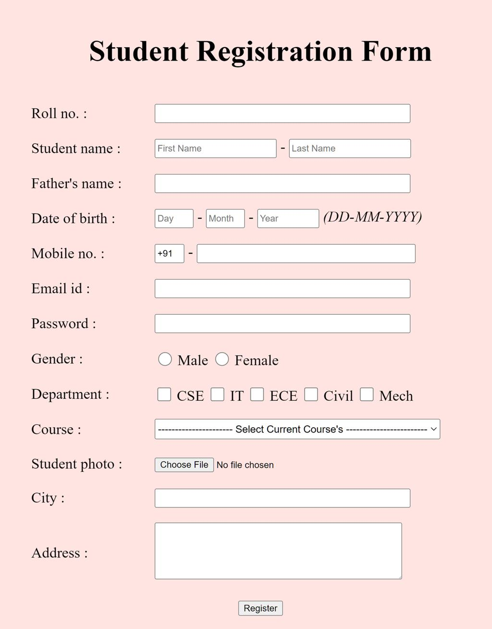
Project Submission Output
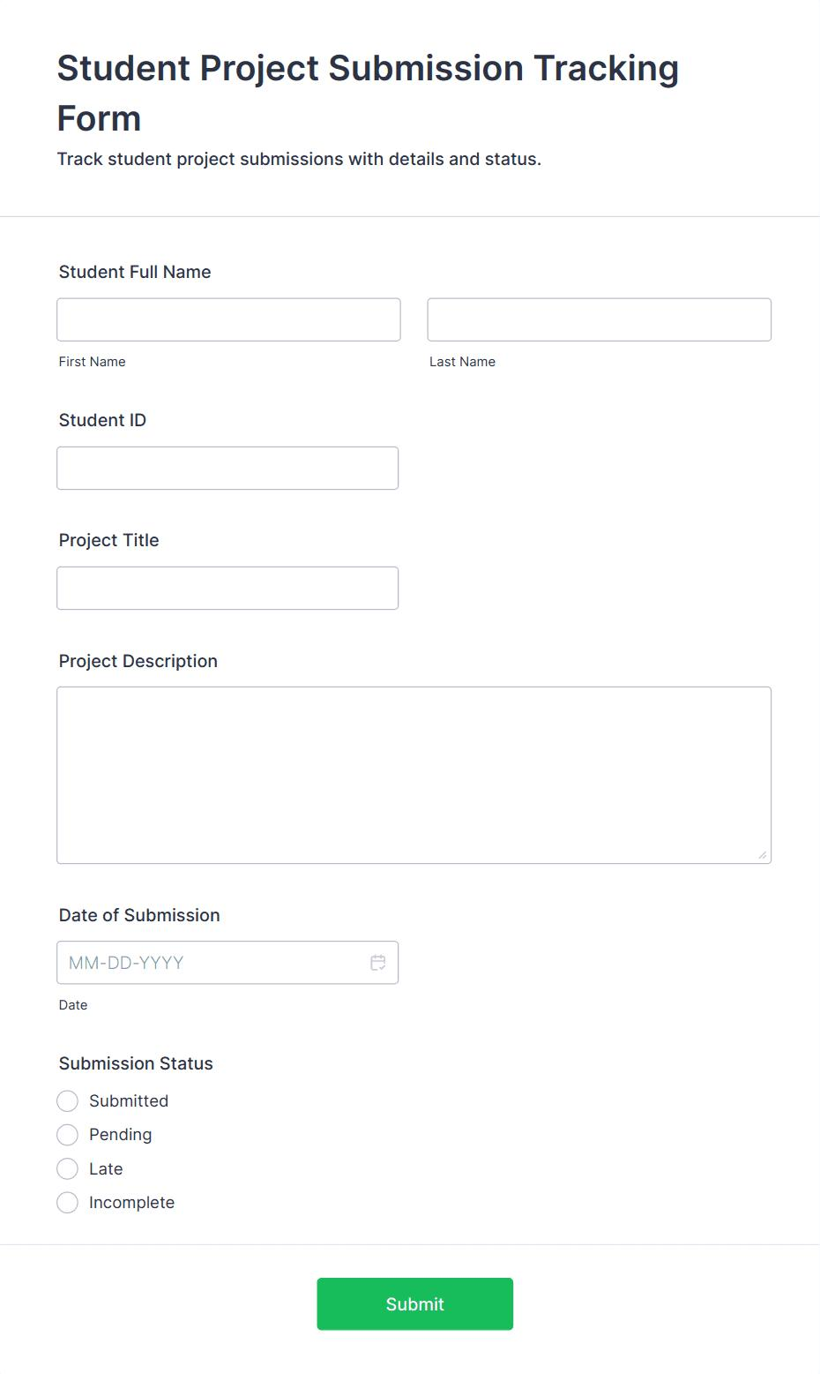
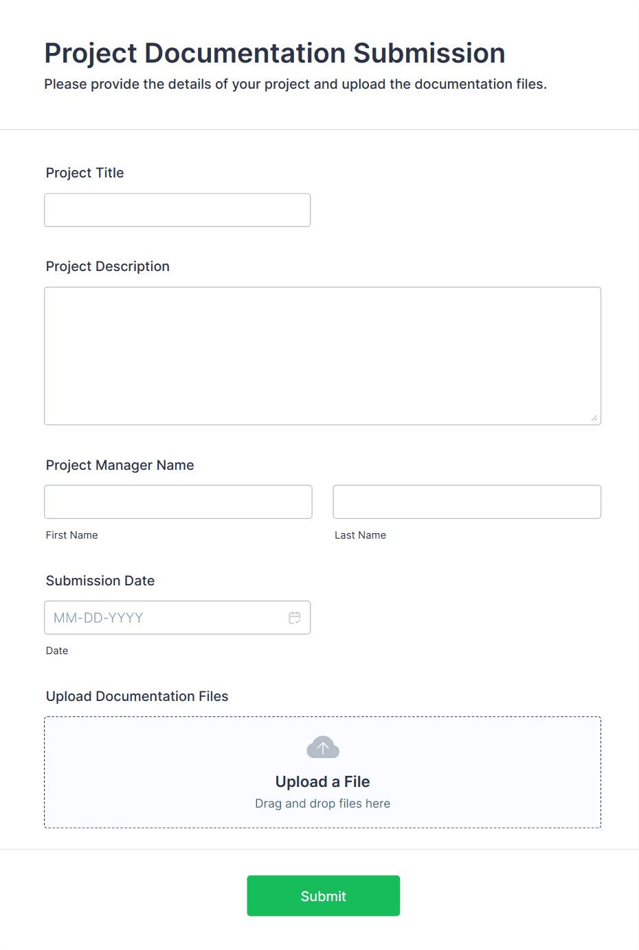
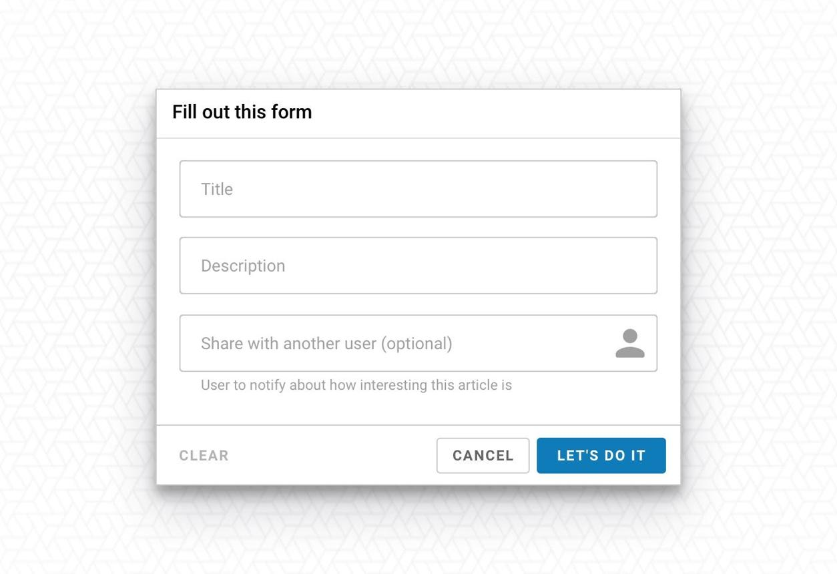


Admin Approval Dashboard
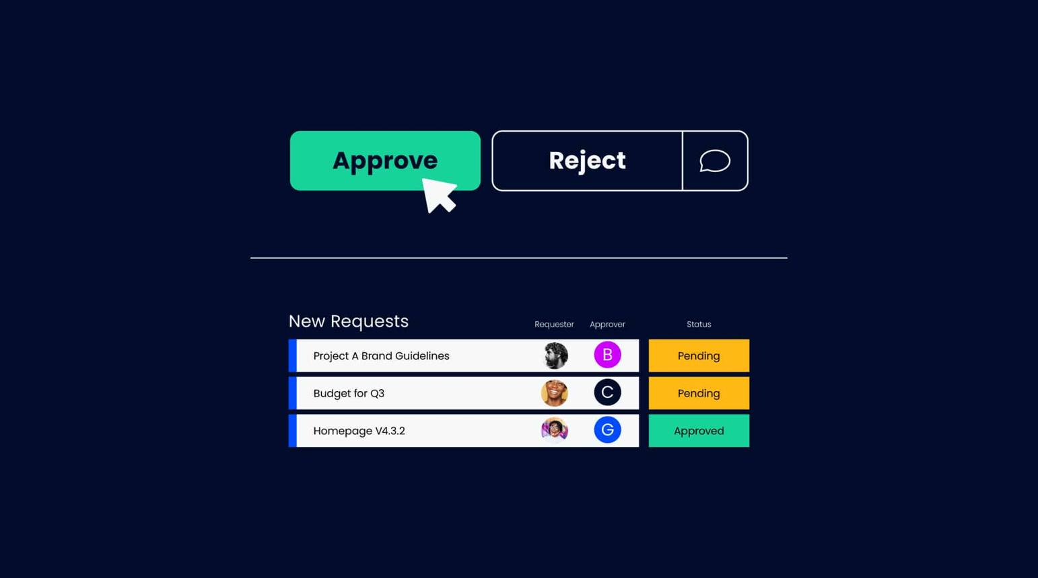
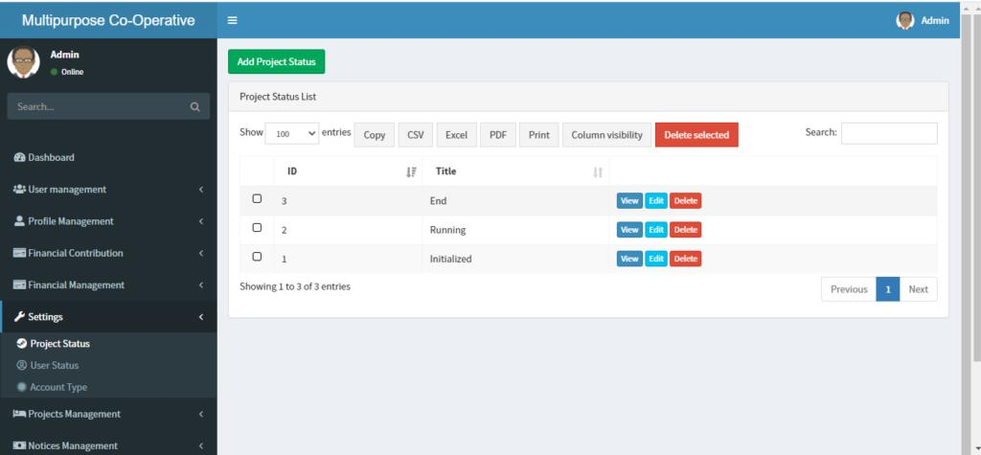
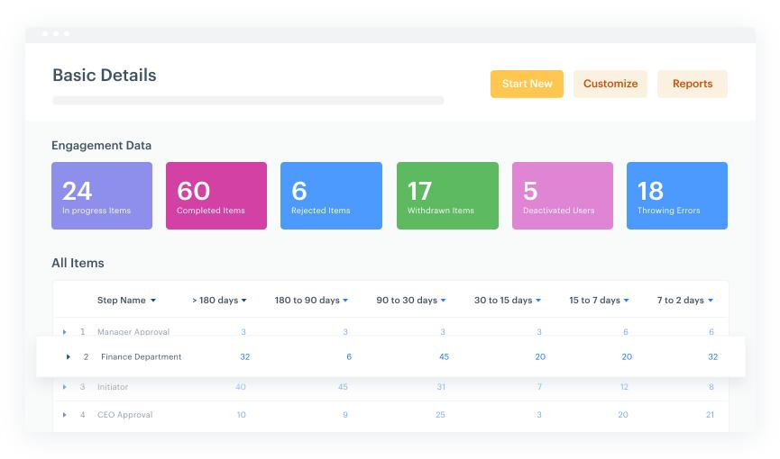

Output Result / Status Page
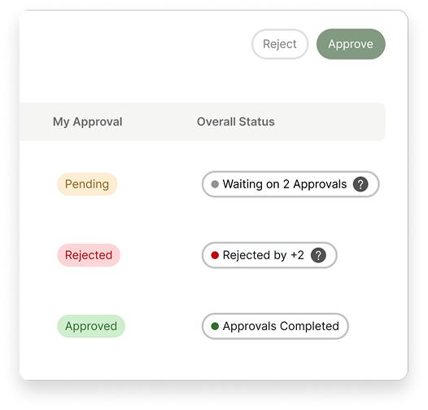
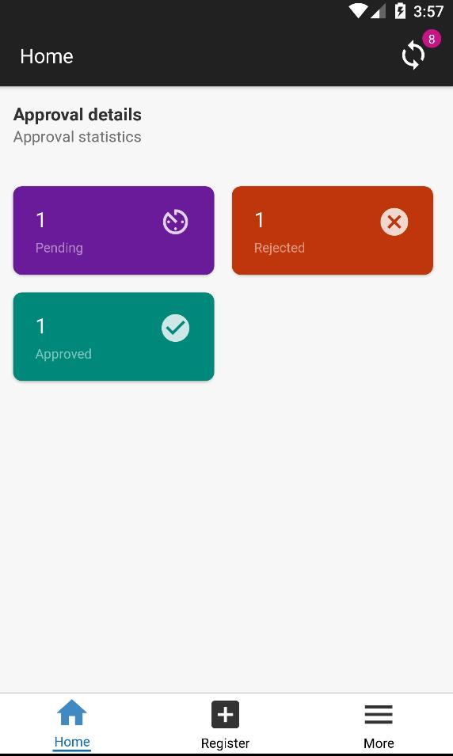
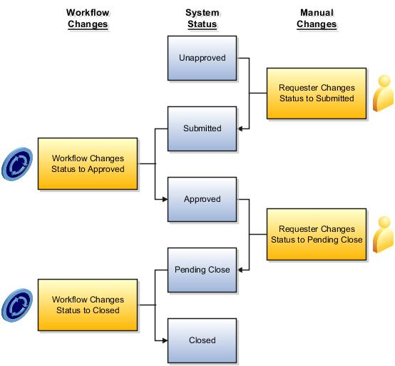

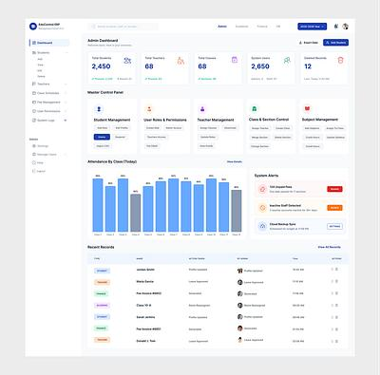

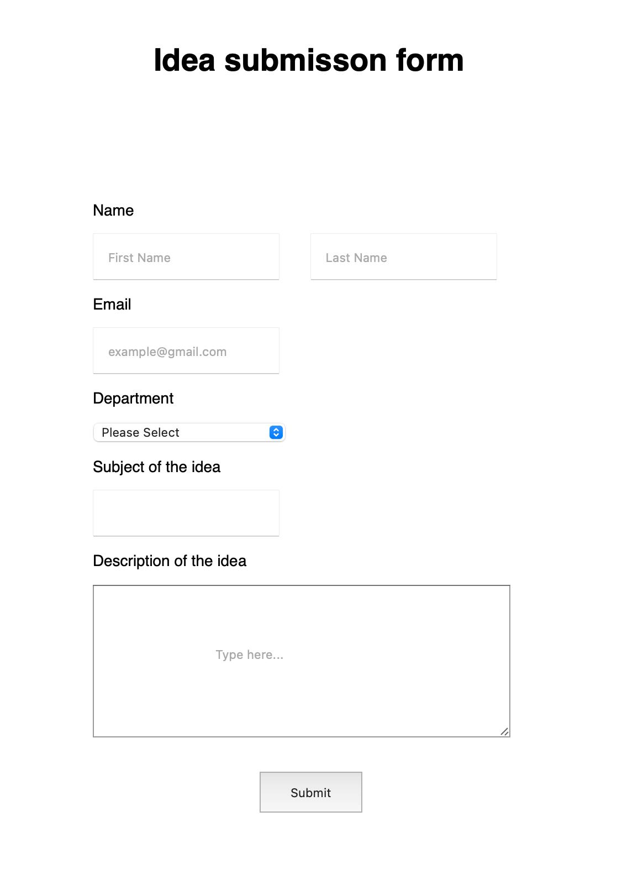

8. CONCLUSION AND FUTURE SCOPE
8.1 Conclusion
The Project Approval System has been successfully designed and developed as a web-based application to automate the process of project submission, evaluation, and approval. This system addresses the major issues present in traditional manual methods, such as delays, lack of transparency, and difficulty in managing project records.
By implementing this system, users such as students or employees can easily submit their project proposals through an online interface, eliminating the need for physical paperwork. The system provides a structured workflow where each project is reviewed by authorized personnel such as guides or administrators. Based on the evaluation, projects can be approved, rejected, or returned for modification with proper feedback.
One of the key advantages of this system is its ability to provide real-time status tracking, which allows users to monitor the progress of their submissions at any time. This improves transparency and reduces confusion in the approval process. Additionally, the system maintains a centralized database that securely stores all project-related information, ensuring easy access and better data management.
The use of modern web technologies such as HTML, CSS, JavaScript, PHP, and MySQL makes the system reliable, scalable, and efficient. The modular design approach ensures that each component of the system functions independently, making it easier to maintain and update in the future.
Furthermore, the system improves communication between users and administrators by providing a clear and organized platform for interaction. It reduces manual errors, saves time, and increases overall productivity. The user-friendly interface ensures that even users with basic technical knowledge can operate the system effectively.
In conclusion, the Project Approval System is a practical and efficient solution that enhances the project management process by automating workflows, improving data handling, and ensuring faster decision-making.

8.2 Future Enhancements
Although the Project Approval System is functional and efficient, there are several enhancements that can be implemented in the future to further improve its performance and usability.
One important enhancement is the development of a mobile application version of the system. This will allow users to access the platform from their smartphones, making it more convenient and accessible. Users will be able to submit projects, check status, and receive updates anytime and anywhere.
Another major improvement is the integration of a notification system. Email or SMS notifications can be added to inform users about important updates such as project approval, rejection, or required modifications. This will enhance communication and ensure that users do not miss any important information.
The system can also be enhanced by incorporating role-based dashboards with advanced analytics. For example, administrators can view reports on the number of projects submitted, approved, or pending. This will help in better decision-making and performance analysis.
In the future, Artificial Intelligence (AI) can be integrated into the system to provide smart suggestions and automated evaluation of project proposals. AI can help in checking project uniqueness, detecting plagiarism, and recommending improvements, thereby reducing the workload of reviewers.Another possible enhancement is cloud-based deployment, which will improve scalability, data security, and accessibility. Cloud integration ensures that the system can handle a large number of users and data without performance issues.
Security can also be improved by implementing advanced features such as data encryption, two-factor authentication, and secure login mechanisms. This will protect sensitive project information from unauthorized access.
Finally, the system can be integrated with other institutional systems such as student databases, learning management systems, or HR systems to create a fully connected digital ecosystem.
Overall, these future enhancements will make the Project Approval System more powerful, intelligent, and user-friendly, ensuring its long-term usability and effectiveness in real-world applications.
9 APPENDIX
The Appendix section contains additional information that supports the main content of the report but is not included in the main chapters to avoid interruption in flow. It provides detailed data, screenshots, code samples, and other relevant materials that help in better understanding of the Project Approval System.

9.1 System Screenshots
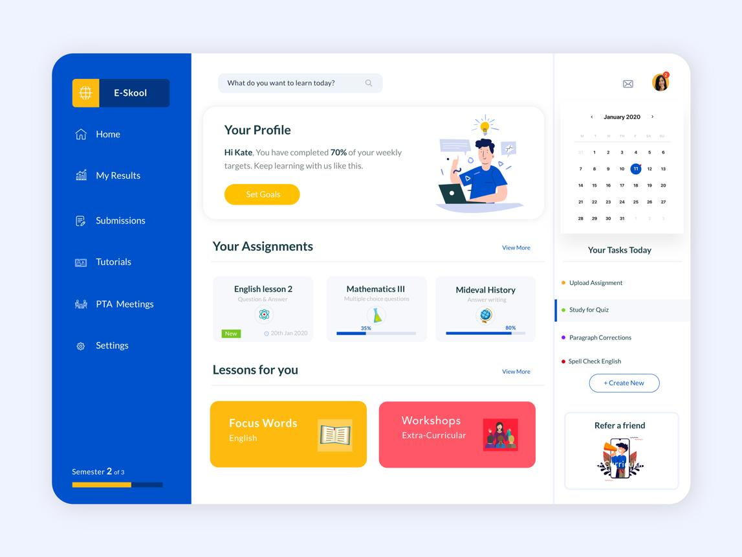
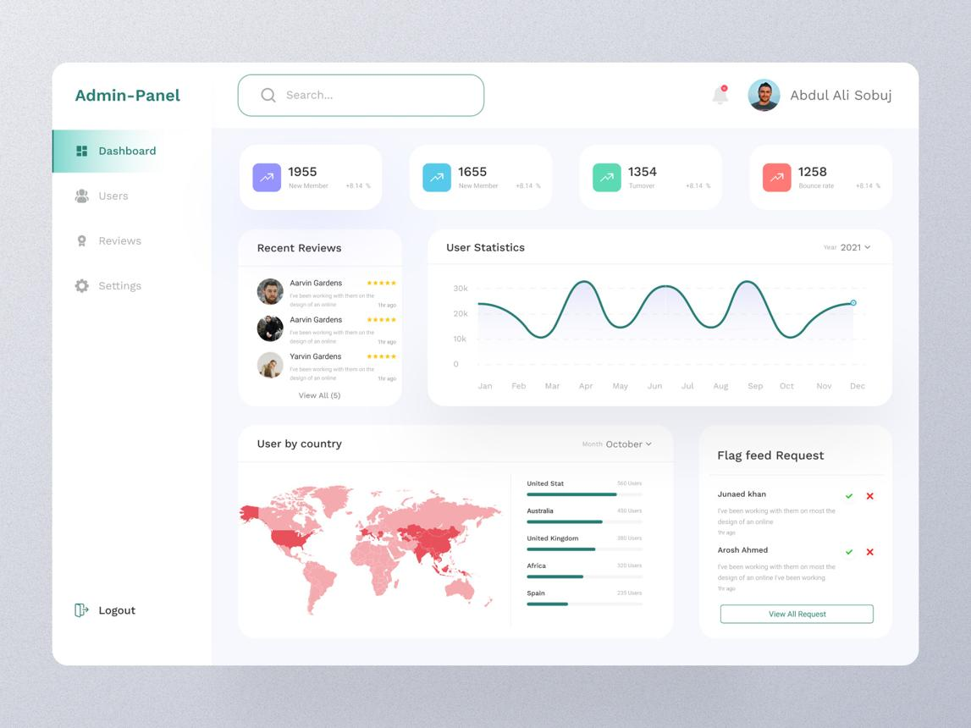
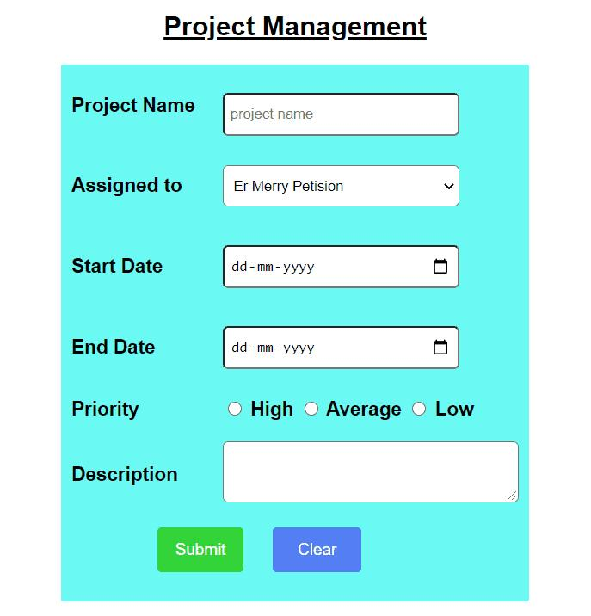

This section includes screenshots of various modules of the system to demonstrate how the application works in real-time.

Some important screenshots include:
- Login Page: Displays the user authentication interface where users enter their credentials to access the system.
- User Dashboard: Shows the main interface after login where users can view project status and options.
- Project Submission Form: Allows users to enter project details and submit proposals.
- Admin Approval Page: Enables administrators to review, approve, or reject submitted projects.
Each screenshot should be properly labeled and provided with a short description explaining its functionality.

9.2 Sample Code Snippets
This section contains important parts of the code used in the system. These code snippets help to understand how the system is implemented.
Example: Database Connection Code (PHP)
<?php
$conn = mysqli_connect("localhost", "root", "", "project_db");
if(!$conn){
die("Connection Failed: " . mysqli_connect_error());
}
?>

Example: Login Validation Code

<?php
$username = $_POST['username'];
$password = $_POST['password'];

$query = "SELECT * FROM users WHERE username='$username' AND password='$password'";
$result = mysqli_query($conn, $query);

if(mysqli_num_rows($result) > 0){
echo "Login Successful";
} else {
echo "Invalid Credentials";
}
?>

9.3 Database Design
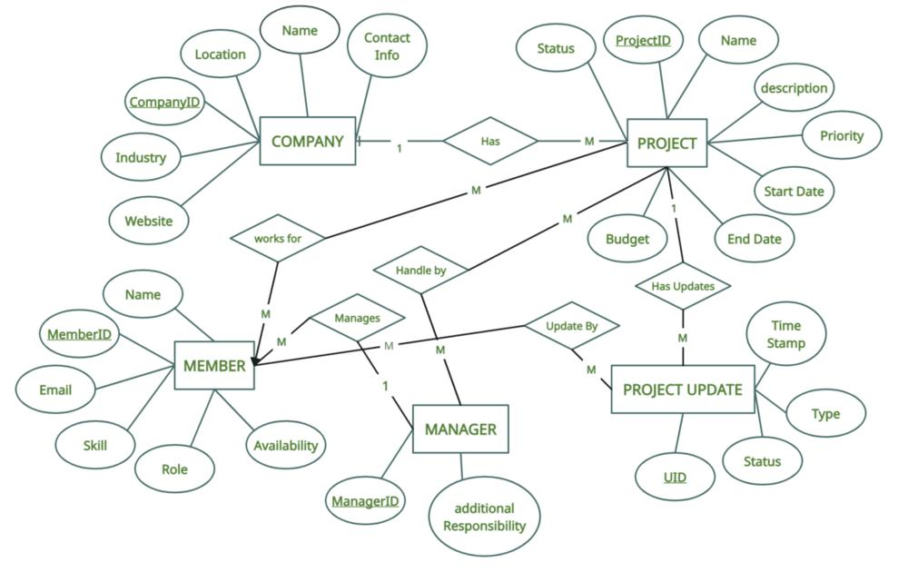
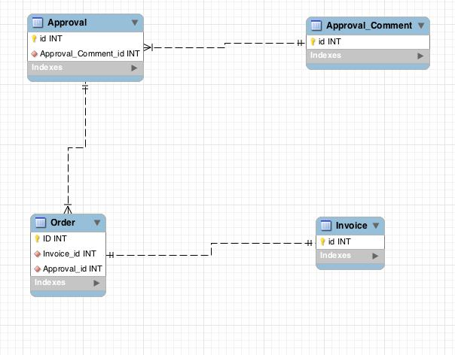
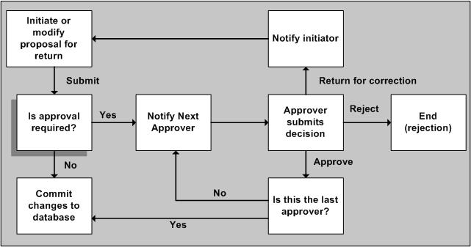
7
The system uses a relational database to store all data. Some important tables include:
- Users Table: Stores user details like ID, name, email, password, and role
- Projects Table: Contains project title, description, submission date, and status
- Approval Table: Stores approval details such as reviewer comments and approval status
This structure ensures efficient data storage and retrieval.

9.4 Test Case Samples
This section includes sample test cases used to verify system functionality.
Test Case ID | Description | Input Data | Expected Output | Result
TC01 | Login Test | Valid credentials | Login Successful | Pass
TC02 | Invalid Login | Wrong password | Error message | Pass
TC03 | Project Submission | Valid data | Submission success | Pass
TC04 | Approval Process | Approve action | Status updated | Pass
These test cases ensure that all modules are working correctly.

9.5 User Manual
This section provides basic instructions for using the system:
- Open the application in a web browser
- Register or login using valid credentials
- Submit a new project using the submission form
- Check project status in the dashboard
- Admin can review and approve/reject projects

Final Statement

The successful development and implementation of the Project Approval System demonstrate the importance of adopting digital solutions in managing academic and organizational processes. This project has effectively transformed the traditional manual approval workflow into a structured, automated, and efficient system.

Throughout the development of this system, various concepts of software engineering such as system analysis, design, implementation, and testing have been applied in a practical manner. The system not only fulfills its primary objective of simplifying the project approval process but also ensures accuracy, transparency, and better communication among users.

By providing a centralized platform, the system minimizes delays, reduces paperwork, and enhances productivity. It enables users to submit, review, and track projects in a seamless manner, thereby improving the overall efficiency of project management. The modular and scalable design of the system also ensures that it can be easily upgraded and extended with new features in the future.

This project serves as a valuable learning experience by bridging theoretical knowledge with real-world application. It highlights how technology can be used to solve practical problems and improve existing systems. The knowledge and skills gained during this project development can be applied in future software development tasks and professional environments.

In conclusion, the Project Approval System stands as a reliable, efficient, and user-friendly solution that meets current requirements and has the potential to evolve with future technological advancements. It reflects the growing need for automation in modern systems and emphasizes the role of software engineering in building effective digital solutions.

References

Ian Sommerville, Software Engineering, 10th Edition, Pearson Education, 2016.

Roger S. Pressman, Software Engineering: A Practitioner’s Approach, McGraw-Hill, 2014.

Ramez Elmasri and Shamkant B. Navathe, Fundamentals of Database Systems, Pearson, 2016.

Efraim Turban, Information Technology for Management, Wiley, 2015.

Abraham Silberschatz, Henry F. Korth, and S. Sudarshan, Database System Concepts, McGraw-Hill, 2019.

World Wide Web Consortium, “HTML and Web Standards Documentation,” 2020.

Oracle Corporation, “MySQL Documentation,” 2021.

Apache Friends, “XAMPP Control Panel Documentation,” 2020.

PHP Group, “PHP Official Documentation,” 2021.

Mozilla Foundation, “MDN Web Docs – HTML, CSS, JavaScript Guides,” 2022.

Web Application Design, Web Application Design and Development, McGraw-Hill, 2018.

Software Engineering Research Papers on Web-Based Management Systems, IEEE Journals, 2015–2022.

